Problems and how we solved them:

1. We could not start the prototype in lab 7 and it was just a black screen

Process: We held a zoom meeting with an undergrad TA, he helped us check the laptop’s settings.

Solution: We had to make sure the file destination was correct.

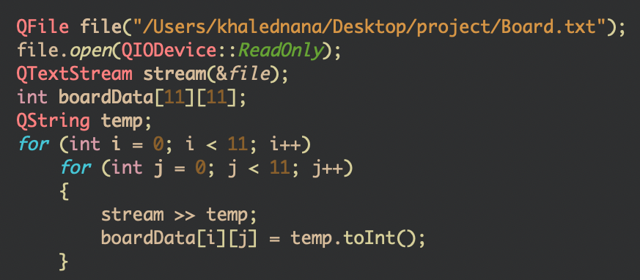

1. Getting the enemy to move randomly was very difficult even though we tried a function that just keeps moving and changes direction once we hit a wall

Solution:A function that takes Random number generator from 1-4 and a direction movement associated with every number and a qtimer to call that function every 500 milliseconds

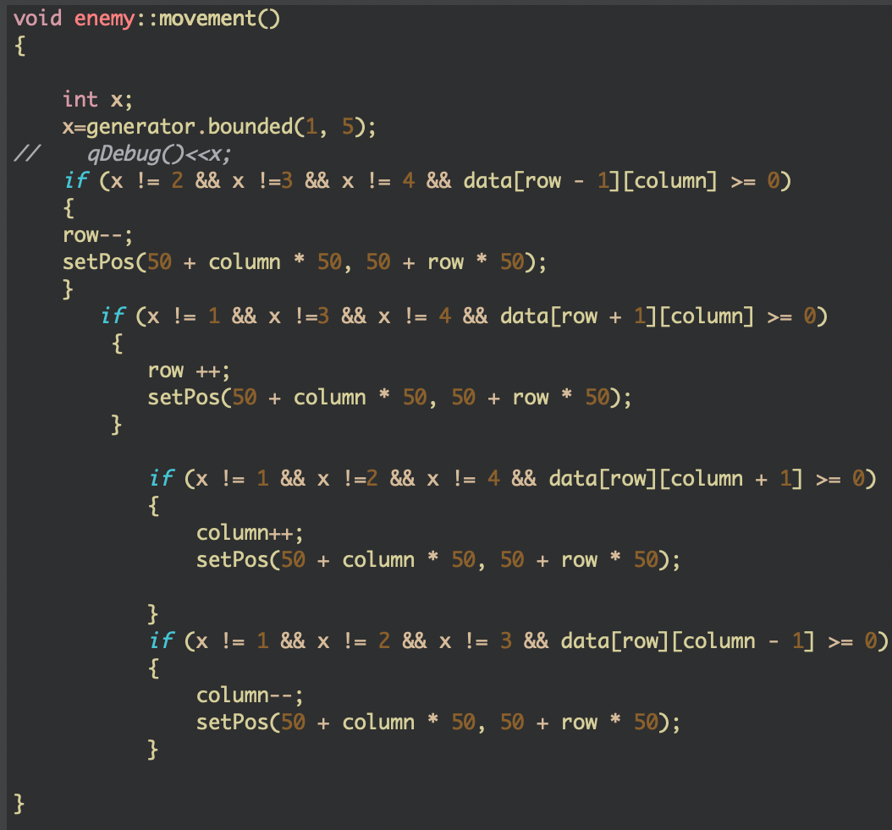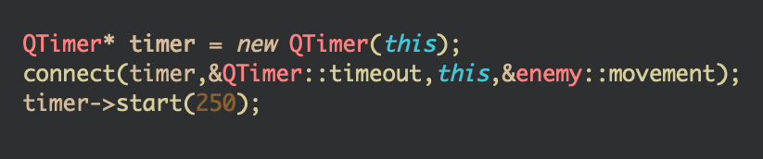

1. Getting the player to change shape for a certain amount of time after eating the power pellet

Solution: As soon as he eats the pellet the photo is changed and a single shot timer is activated to return him back to the old shape

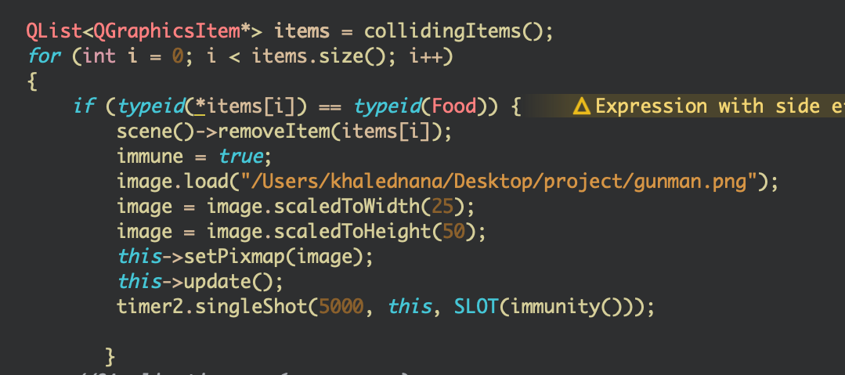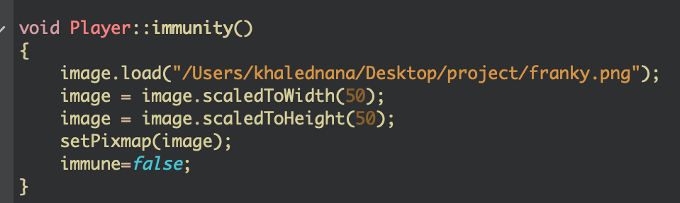

1. After getting the enemy to move randomly, we created 2 different objects of the same class. However, the same generator worked for the 2 objects which led to the same movements from the 2.

Solution: We created a new class for a new enemy, so that it includes a new generator.



1. In order to display the number of lives on the screen, we created 3 objects of type heart. Each should disappear whenever the player collides with one of the enemies. We could only get the first heart to vanish even though the collision counts and the game ends after the third collision. The 2 other hearts would still remain on the screen.

Solution: Instead of declaring an array of 3 objects of type heart, we switched to 3 objects that aren’t in an array.

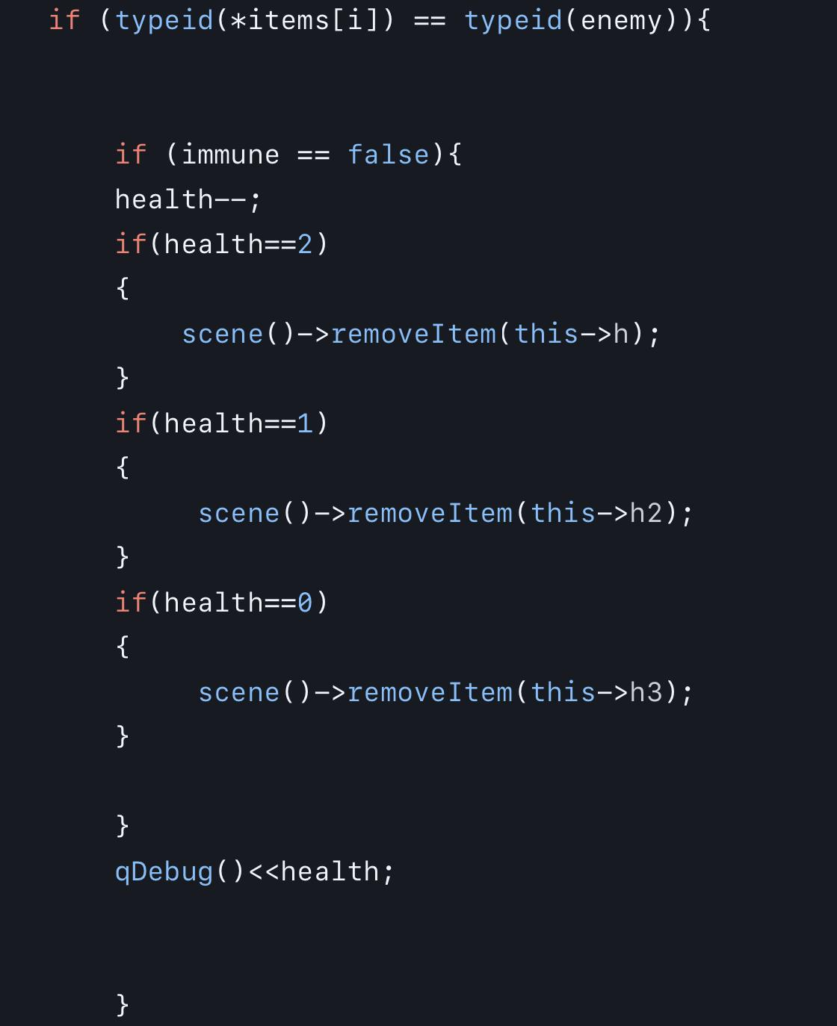

1. One of the main problems we encountered was the enemies being eliminated from the game. We tried to do it like we did with the player (franklin) ; however, we failed so the enemies did not vanish from the game; nevertheless, their lives decrease when they get shot.